|  |  |  |  |
| --- | --- | --- | --- |
|  | Bansilal Ramnath Agarwal Charitable Trust's Vishwakarma Institute of Information Technology  **Department of**  **Artificial Intelligence and Data Science** | | |
| Name: Sakshi Vijay Darandale | | | |
| Class: TY | Division: A | | Roll No: 371017 |
| Semester: V | | Academic Year:2022-2023 | |
| Subject Name & Code: Cloud Computing and Analytics | | | |
| Title of Assignment: To create and access VM instances and demonstrate various components such as EC2, S3, Simple DB, DynamoDB. | | | |
| Date of Performance: 2/09/2022 | | Date of Submission: 05/12/2022 | |

Aim: To create and access VM instances and demonstrate various components such as EC2, S3, Simple DB, DynamoDB.

Problem Statement: To create and access VM instances and demonstrate various components such as EC2, S3, Simple DB, DynamoDB.

Background Information:

* An **instance** in cloud computing is a server resource provided by third-party cloud services. While you can manage and maintain physical server resources on premises, it is costly and inefficient to do so.
* A **virtual machine** is a computer that exists in the virtual environment. Virtual machines use the compute resources that are available in the physical computer. However, those compute resources, such as processing power and memory, are not in the form of physical hardware. Instead, they are provided and managed as code within the physical computer.
* **Instance vs. virtual machine**: You can run multiple virtual machines on a single computer, but when you run virtual machines in the cloud environment, they are known as instances. Running virtual machines on the cloud allows organizations to benefit from the cost effectiveness of sharing and scaling resources.
* There are two main benefits of cloud instances: Scalability, Fault tolerance.
* An **instance group** is a collection of many instances that share the same configuration. Developers use instance groups to set uniform policies and rules across multiple instances easily. All instances in an instance group go through the same lifecycle simultaneously.
  + **Single instance vs. multi-instance:** Single instance describes a cloud infrastructure setup where only one instance of the compute resources is created and allocated to the user. Meanwhile, multi-instance is a term used for more than one identical instance that run parallel to each other. In a multi-instance setup, each instance has its own compute resources.
* **AWS Elastic Compute Cloud (Amazon EC2)** allows developers to build scalable apps in the cloud environment. Amazon EC2 offers several types of instances that are optimized for different workloads.

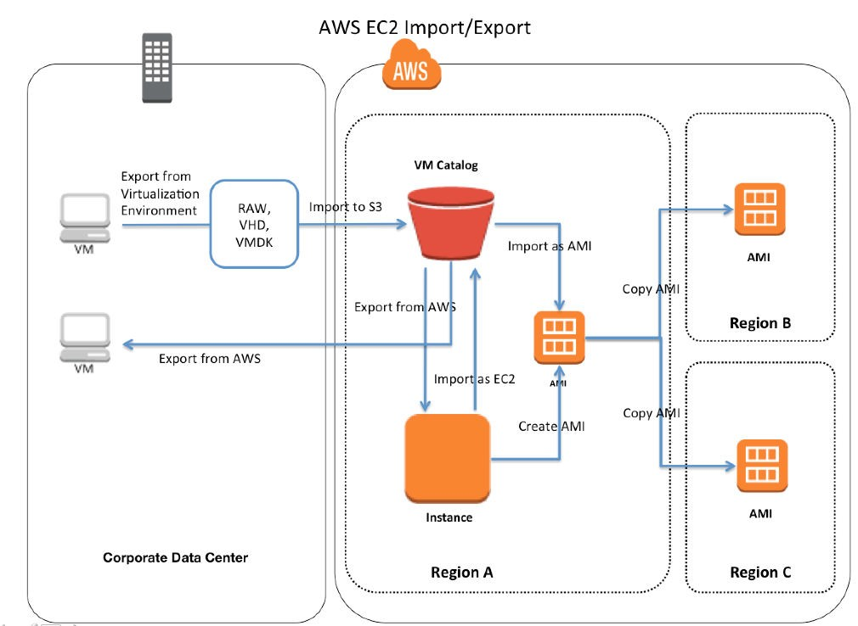

Cloud Resource Requirements: AWS Steps:

**AWS : Creating a Virtual Machine with EC2**

**Step 1:** Log in to “AWS Management Console”.

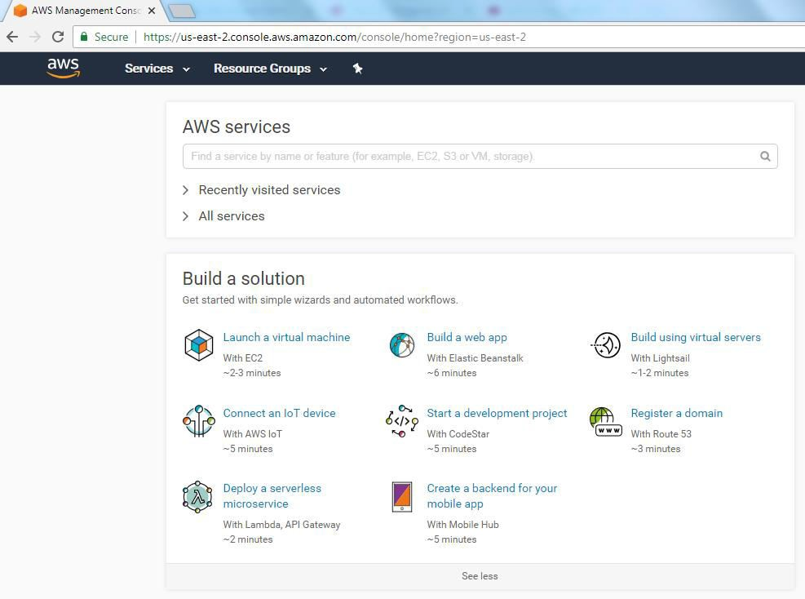

**Step 2:** Under the *Build Solution* group, click on the “Launch a virtual machine” link. AWS will open a wizard

to allow us to create a Virtual Machine instance (EC2 instance).

**Step 3:** Choose an Amazon Machine Image (AMI) that contains the software configuration required to launch the EC2 instance. Select the AMI which is suitable for your need by clicking on the **Select** button next to the displayed AMI template. Once selected, the Console will take us to the next step to select an instance from the *“Choose an Instance Type”* wizard page.

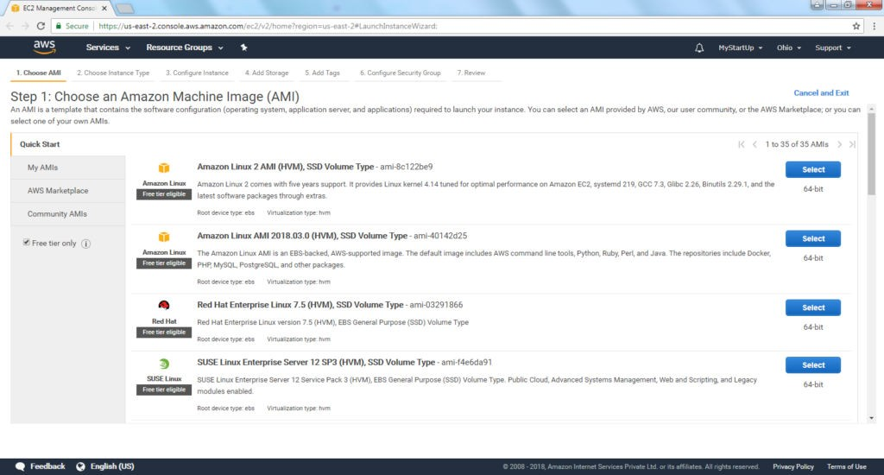

**Step 4:** Select the instance type which suits our requirement, and click on **“Next: Configure Instance**

**Step 5:** *“Configure Instance Details”* allows you to configure the instance to suit your requirements. Keep the default values, if you do not want to modify anything.

* Give a number of instances value in the “Number of instances” field; to launch the number of instances from the same selected AMI.
* You can assign the access management role to the Instance through the “IAM role” field.

Once the necessary values are entered, click on the **“Next: Add Storage”** button to add the storage to the instance(s).

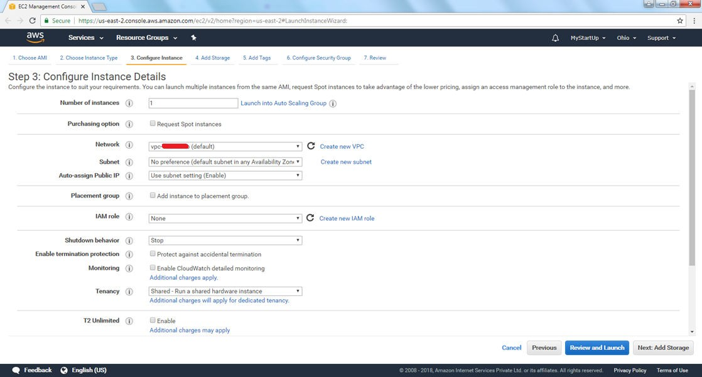

**Step 6:** The *“Add Storage”* wizard page, allows you to update the storage device settings. You can also add new volumes depending on your requirements. Once the values are given, click on the **“Next: Add**

**Tags”** button.

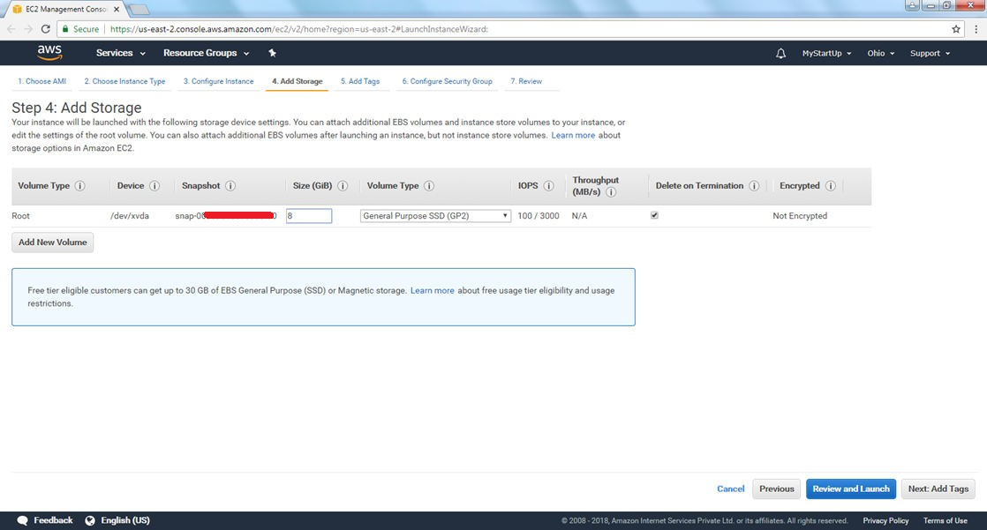

**Step 7:** After adding the Tags, click on the **“Next: Configure Security Group”** button.

**Step 8:** “Configure Security Group” wizard allows to add rules to control the traffic for the EC2

instance. Once required changes are done, click on the **“Review and Launch”** button.

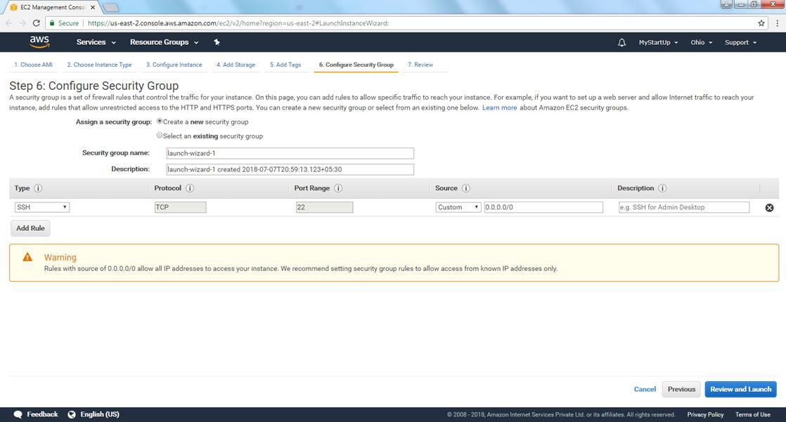

**Step 9:** Before launching the instance, AWS Management Console will prompt a message, to create a key pair entry to attach to the instance. You can create a new key pair or you can use the already created one. This key pair is important to connect to the EC2 instance. Key pair contains both public & private keys. You need to download the Key Pair and store it in a secured location from where you can access it whenever you want to connect to the EC2 instance.

Provide the *“Key pair name”* & click on the **Download Key Pair** button to download the key pair file (*.pem file). Once downloaded, click on the **Launch Instances** button to launch the EC2 instances.

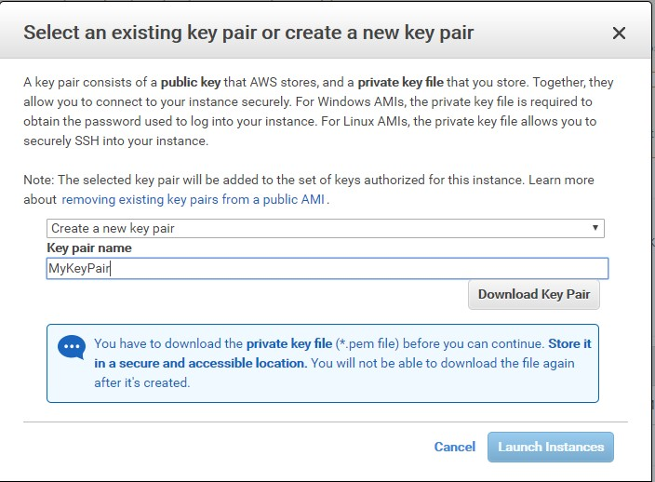

**Step 10:** If everything goes fine, you will see the **“Your instances are now launching”** message. And you can also review the settings you have done. Click on the **“View Instances”** button to view the instances which we created just now through the above steps.

**Step 11:** You can see the list of instances and their statuses on the instances page. Now the EC2 instance is ready, which means, your own virtual machine is ready. Everything is ready; then how to connect to it.?

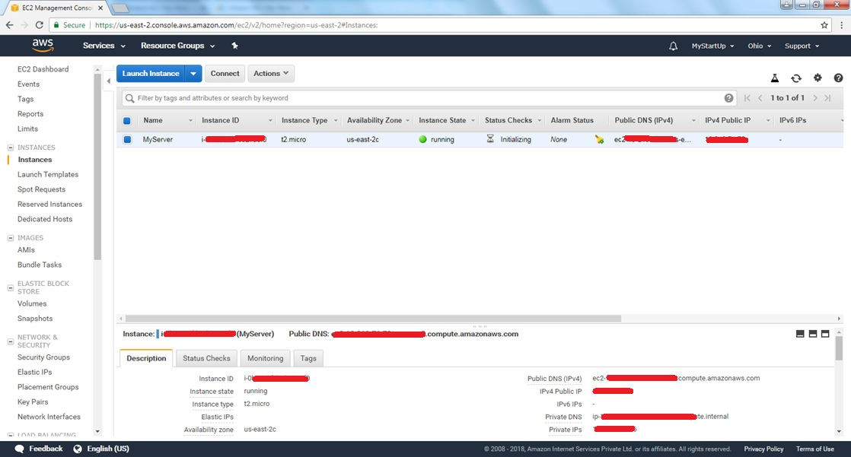

**Step 12:** Click on **Connect** button, which is on top of the EC2 instances page. AWS Management Console will display the steps to connect to the EC2 instances. You can connect to EC2 instances, using an SSH client or through a web browser.

GitHub Repo Link:

<https://github.com/Sakshid18/Cloud-Computing-and-Analysis>

Conclusion:

You can use Amazon EC2 to launch as many or as few virtual servers as you need, configure security and networking, and manage storage. Amazon EC2 enables you to scale up or down to handle

changes in requirements or spikes in popularity, reducing your need to forecast traffic.